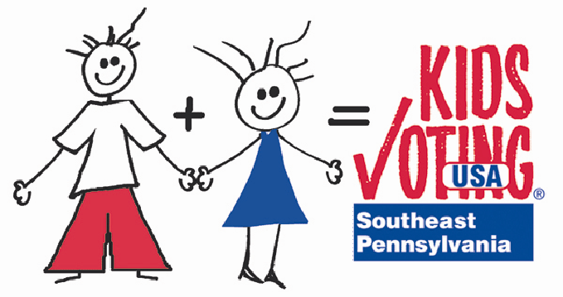
Constitution Day, Election Day and General Civics Links

American Bar Association
Ideas for Constitution Day 2010 by the American Bar Association

American Bar Association - Constitution Day 2009
Classroom lessons from the American Bar Association from Constitution Day 2009

Bill of Rights Institute
Celebrate Constitution Day with your students with a fun, interactive game from the Bill of Rights Institute. Our newest Web resource, Life Without the Bill of Rights? is a click and explore activity that puts your students in control: How would life change without some of our most cherished freedoms. Life Without the Bill of Rights, invites your students to understand the significance of their constitutionally-protected rights including freedom of religion, speech, and press, freedom from unreasonable search and seizure, and the rights of private property.

What is the Judicial Branch?
Lesson plan for grades 4-6 called What is the Judicial branch?

PA Bar Association
Lessons, activities, programs, resources related to the Constitution

You Tube
In the search box, type in SchoolHouse Rock The Preamble

A to Z Teacher Stuff
Links to lessons plans and ideas for Constitution Day

Constitutional Rights Foundation
Constitution Day lessons broken down by grade level

Education World
Resources for Constitution Day from Education World

Constitution Day
Constitution Day activities, lesson plans and facts

Center for Civic Education
The Center for Civic Education, in collaboration with the American Association of School Administrators, offers lessons suggested for use in grades K-12.

Teach The First Amendment
This website, launched by the John S. and James L. Knight Foundation, provides teachers with free resources to meet the new Congressional requirements for Constitution Day. It links to lesson plans, posters, books and student media assistance, free teaching guides and lesson plans as well as other resources like tools for starting and protecting student newspapers and broadcast stations.

Constitution Day
A National Constitution Center partnership for one-stop linking to programs and curriculum celebrating Constitution Day and for teaching about the Constitution year-round. This site explains how to host your own "I Signed the Constitution" ceremony; connect to a live Justice Talking debate with Supreme Court Justices; stage an America Reads the Constitution event in the community; download free lesson plans from leaders in civic learning and much more.

Lesson Plans Page
Elections Lessons and Teacher Resources

Alabama Learning Exchange
Lesson plan - Analyzing Gubernatorial Debates: The 2010 Election

Voting and the November Election Curricula
What About the Kids lessons plans for teachers regarding governor race. Put out by state of NJ.

Library of Congress — Legislative Resources for Teachers
In the spirit of Thomas Jefferson, the Library of Congress makes federal legislative information freely available to the public and provides legislative and classroom resources for educators at all levels through THOMAS.

PA Bar Assoc. - Law Day 2007
A K-12 2007 Law Day Lesson Plan Guide developed by the Pennsylvania Bar Association, in conjunction with the Pennsylvania Bar Foundation. This unique resource provides judges, lawyers, educators and students with exciting and informational lesson plans, as well as links to other civic learning organizations and materials from around the country.

PA Bar Assoc. - Law Day 2008
A 2008 Law Day Lesson Plan Guide (see above)

Scholastic’s Parent Primer on Democracy and Government
This website gives parents a refresher on the story of the Constitution, the Bill of Rights and other amendments, branches of government as well as a glossary of government related terms. This primer is meant to aid parents in talking to their children about what makes America unique.

Campaign for the Civic Mission of Schools
The national Campaign has an online inventory of practice examples for civic education. These examples show how schools and teachers are educating students for democracy.

Kids.Gov
Official kids' portal for the U.S. government.

CNN Student News
News just for students

PennCORD Lesson Plans
Educator lesson plans and resources from PennCORD (The Pennsylvania Coalition for Representative Democracy (PennCORD) is a unique union of educational, advocacy and governmental organizations committed to improving civic learning for students in grades K-12)

PennCORD Educator Resources
PennCORD web based educator resources

Two Thumbs Up!

The First Lady of the Commonwealth of PA, Judge Marjorie O. Rendell, recommends these books:
For grades K-2:
Amelia Bedelia 4 Mayor, by Herman Parish
Coming to America: The Story of Immigration, by Betsy Maestro
House Mouse, Senate Mouse, by Peter Barnes and Cheryl Barnes
I Am a Good Citizen, by Mary Elizabeth Salzmann
L is for Liberty, Wendy Cheyette Lewison
Martin’s Big Words, by Doreen Rappaport
Pete for President!, by Daisy Alberto
Red, White and Blue: The Story of the American Flag, by John Herman
Saving the Liberty Bell (On My Own History), by Marty Rhodes Figley
So What is Citizenship Anyway?, by Chelsea Luthringer
The American Wei, by Marion Hess Pomeranc
The Fourth of July Story, by Alice Dalgliesh
The Island of the Skrog, by Steven Kellogg
The Story of Ferdinand, by Munro Leaf
The Story of Ruby Bridges, by Robert Coles
Vote!, by Eileen Christelow

For grades 3-6:
A More Perfect Union: The Story of Our Constitution, by Betsy Maestro
A Picture Book of Paul Revere, by David A. Adler
America Is.., by Louise Borden
Betsy Ross, by Alexandra Wallner
Chickens May Not Cross the Road and Other Crazy (but true) Laws, by Kathi Linz
Kids are Citizens, by Ellen Keller
How the U.S. Government Works, by Syl Sobel
Molly’s Pilgrim, by Barbara Cohen
Rosa Parks: My Story, by Rosa Parks
The Big Orange Splot, by Daniel Manus Pinkwater
The Importance of Being an Active Citizen, by Anne Beier
Volunteering for a Political Campaign, by Sheila Klee
We Live Here Too! Kids Talk About Good Citizenship, by Nancy Loewen
We the Kids: The Preamble to the Constitution of the United States, by David Catrow

Video:
This is America Charlie Brown: The Birth of the Constitution
The Peanuts gang goes to Philadelphia, PA, to learn about the Constitution.

